Part 1: Software Development Models

1. What is a Software Development Model?
A software development model is a way of organizing the process of building software.
For example, when building an application, a team normally needs to:
- Understand what the customer wants
- Plan the project
- Design the system
- Write code
- Test it
- Release it
- Maintain and improve it
A development model tells us in what order and in what way these activities should happen.
Think of it like building a house.
- Waterfall: Make the complete plan → build everything → inspect at the end.
- Agile: Build one room → check with the customer → improve → build the next room.
- Prototype: Build a small sample first → show it → understand what the customer actually wants → build the real product.
- Spiral: Build gradually while repeatedly identifying and reducing risks.

2. Waterfall Model
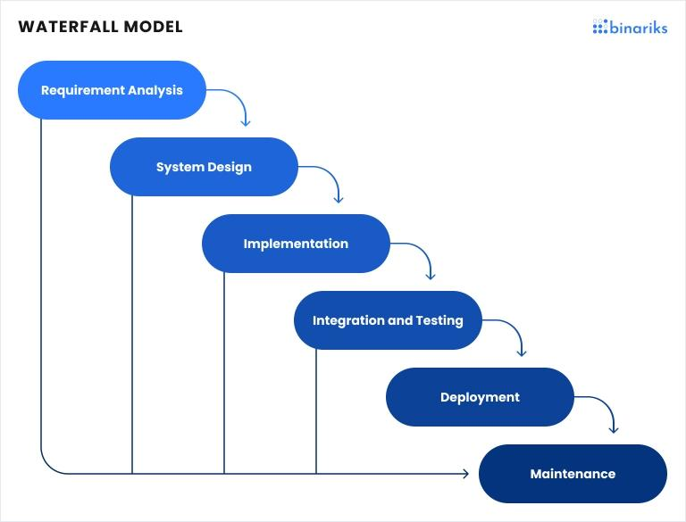
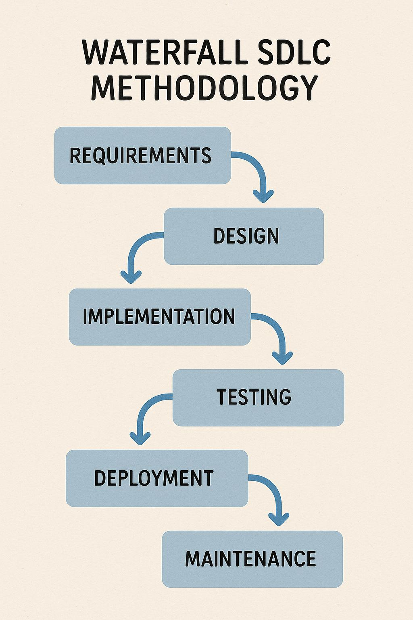
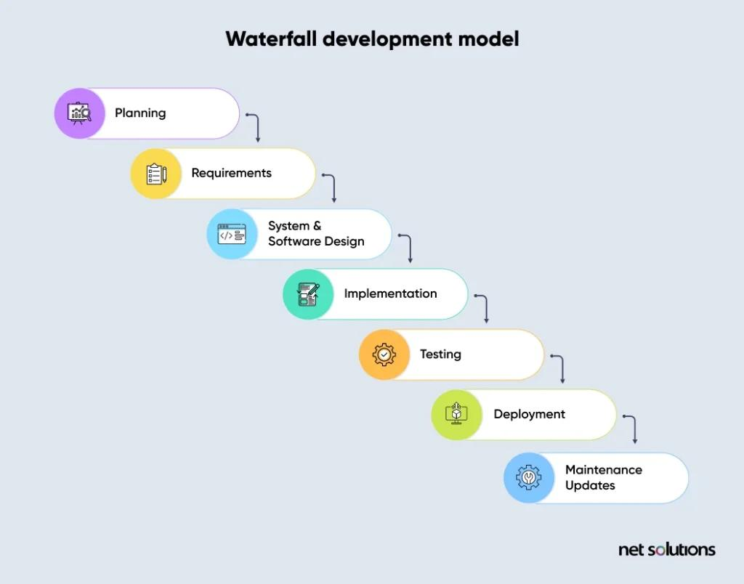
5
The Waterfall model is one of the oldest and simplest development models.
The project moves through a series of stages, usually one after another.

Typical flow
Requirements → Design → Development → Testing → Deployment → Maintenance
For example, imagine you're building a banking application.
First:
"Let's collect all requirements."
Then:
"Let's design the complete application."
Then:
"Let's write the code."
Then:
"Let's test it."
Then:
"Let's release it."

Advantages
- Very easy to understand
- Easy to manage
- Clear documentation
- Clear deadlines and stages
- Works well when requirements are stable

Disadvantages
- Difficult to change requirements later
- Customer usually sees the working product quite late
- Bugs may be discovered late
- Not suitable when requirements are uncertain

When should you use Waterfall?
Good when:
- Requirements are very clear
- Requirements are unlikely to change
- The project is heavily regulated
- Documentation is extremely important

Simple example
Government software where requirements and regulations are defined before development may use a more plan-driven approach.

3. Agile Model
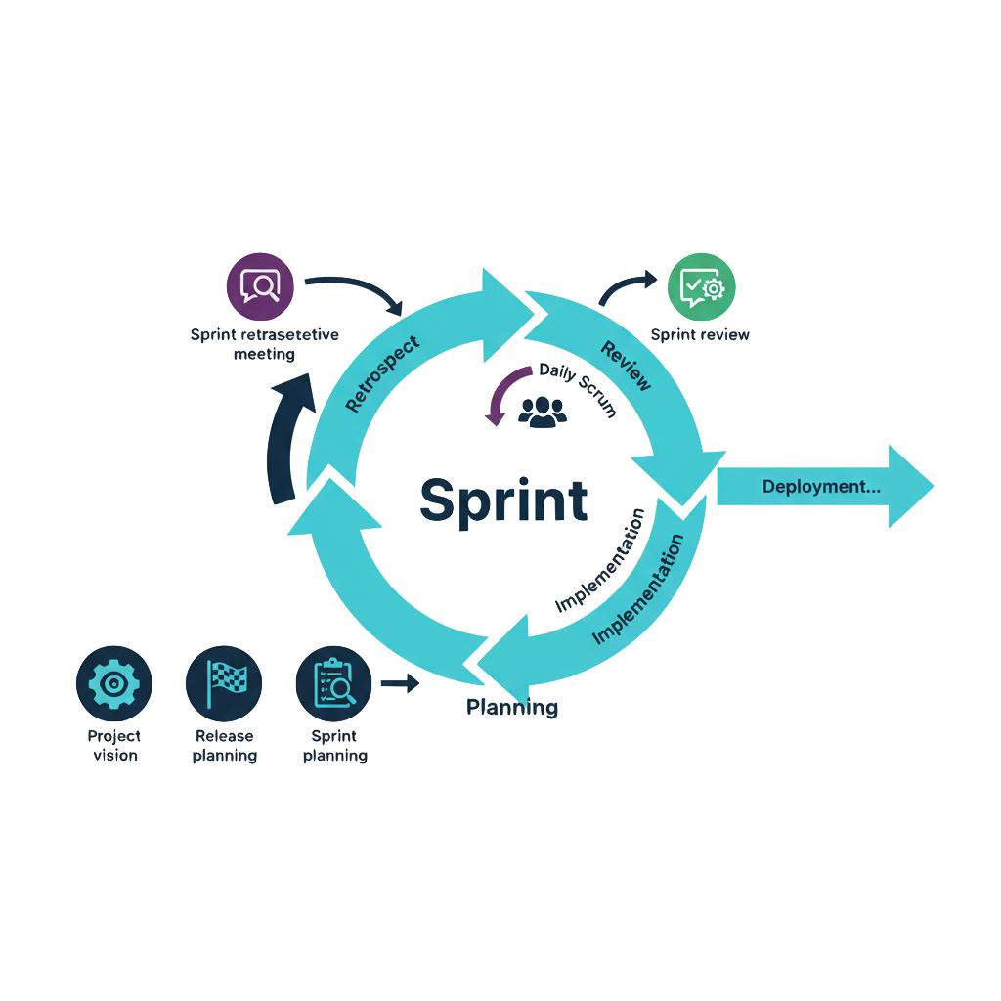
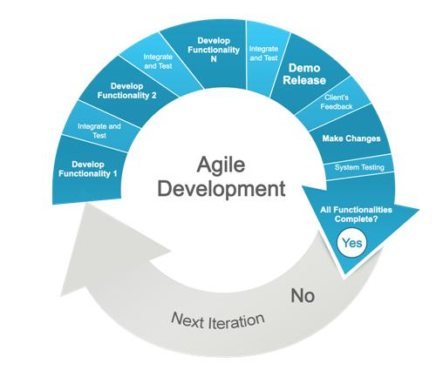
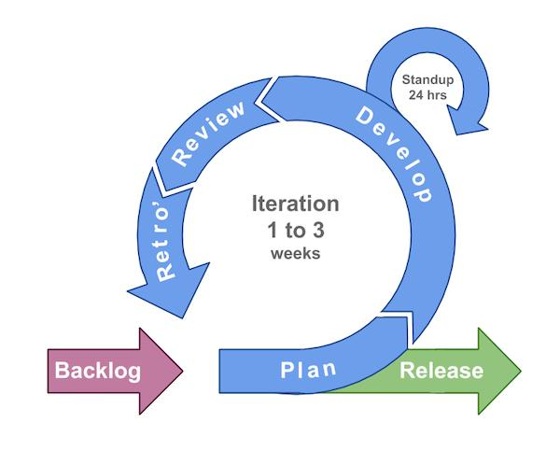
6
Agile is one of the most popular approaches today.
Instead of building the entire application at once, the team builds it in small pieces.
These small development cycles are commonly called iterations or sprints.
For example:

Sprint 1
Build:
- Login
- Registration
Get feedback.

Sprint 2
Build:
- User profile
- Password reset
Get feedback.

Sprint 3
Build:
- Payment
Get feedback.
And so on.

Main idea
Build → Test → Get feedback → Improve → Repeat

Advantages
- Easy to handle changing requirements
- Customer gets working software frequently
- Problems can be discovered early
- Continuous feedback
- Faster delivery of useful features

Disadvantages
- Requires strong communication
- Can be difficult without good planning
- Scope can keep changing
- Documentation may receive less attention if the team handles Agile poorly

Important point
Agile is not one specific process.
Agile is a collection of principles and practices.
Frameworks such as:
- Scrum
- Kanban
- Extreme Programming (XP)
are commonly used to implement Agile ideas.

4. Scrum
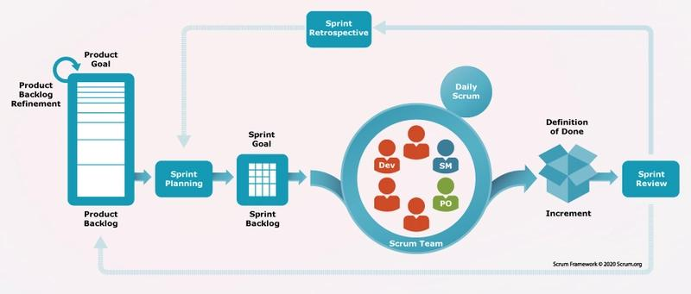
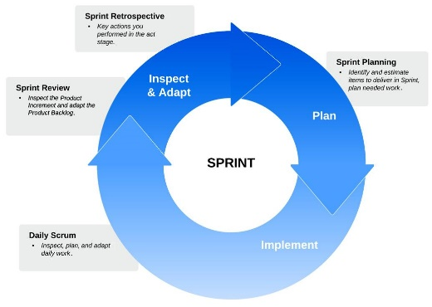
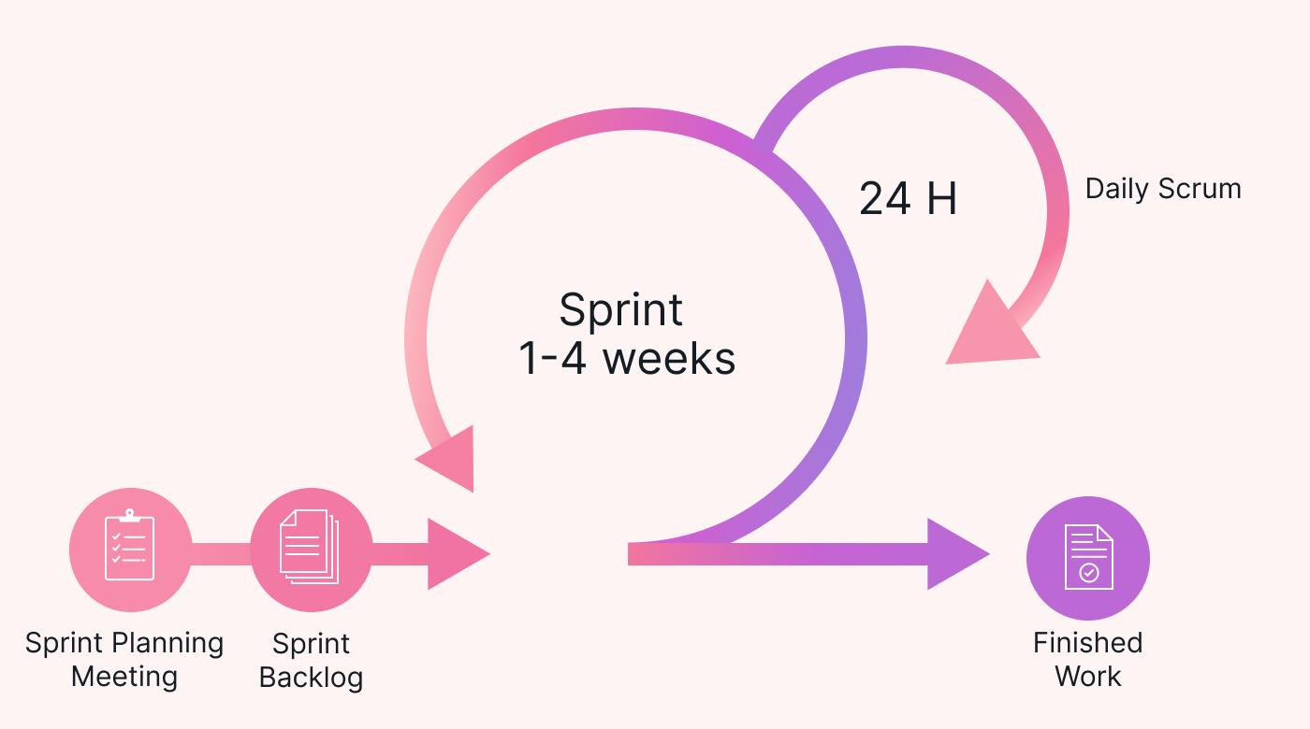
6
Scrum is one of the most commonly used Agile frameworks.
A project is divided into Sprints.
A sprint is usually a fixed period, often 1–4 weeks.

Example
Suppose you're building Amazon-like shopping software.
The team creates a list:
Product Backlog
- Login
- Product search
- Shopping cart
- Payment
- Orders
- Reviews
The team selects some items for the next sprint.
Sprint 1:
- Login
- Product search
After the sprint, the team has a potentially usable increment.
Then another sprint begins.

Common Scrum roles

Product Owner
Decides:
"What should we build?"

Developers
Decide:
"How do we build it?"

Scrum Master
Helps the team follow Scrum and removes process obstacles.

Common Scrum events
- Sprint Planning
- Daily Scrum
- Sprint Review
- Sprint Retrospective

5. Kanban
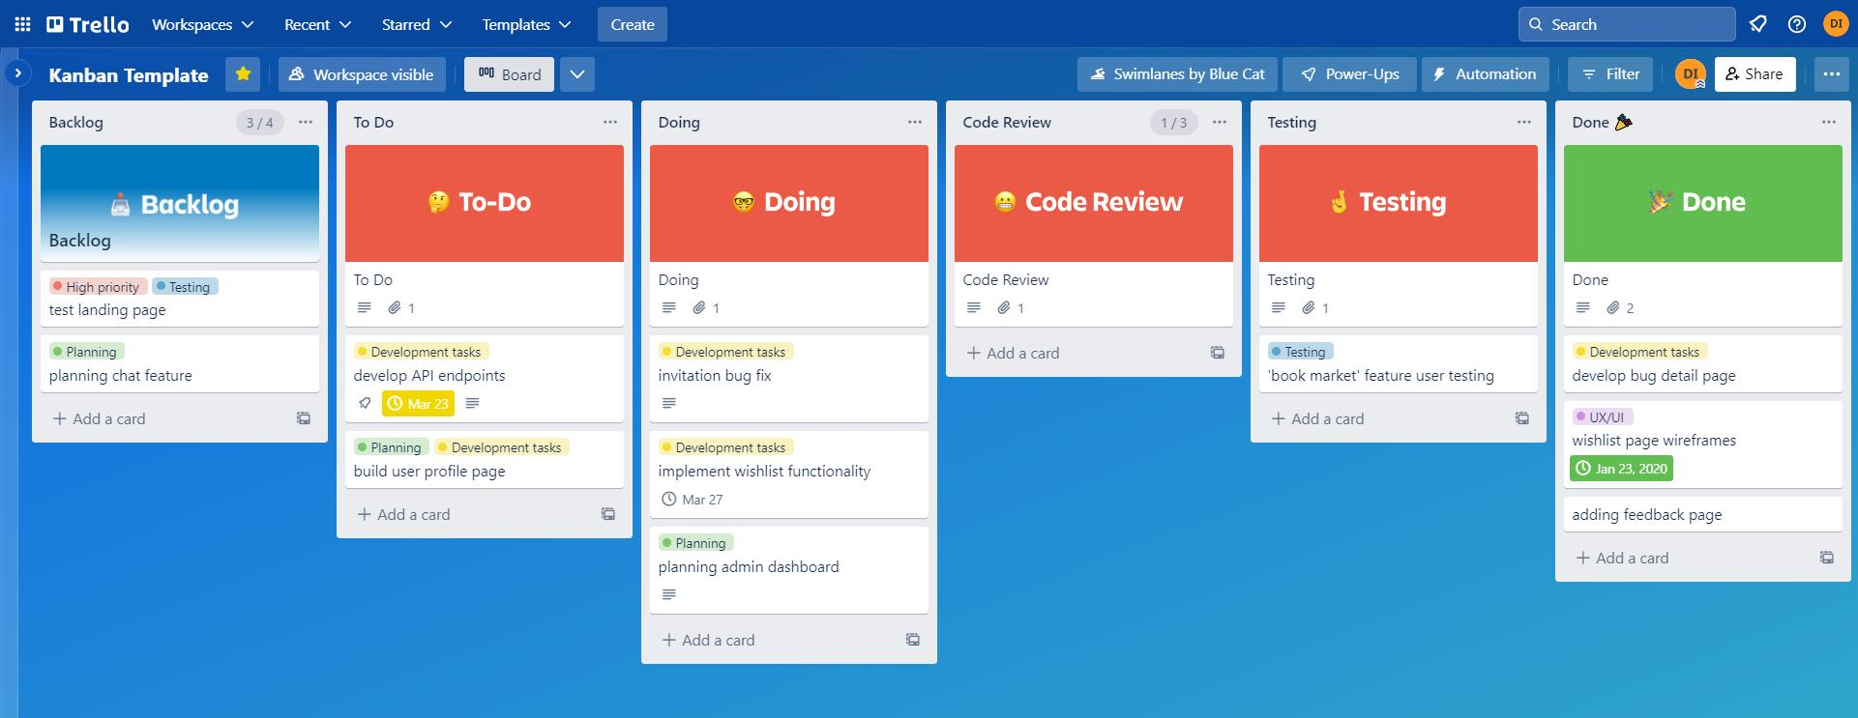
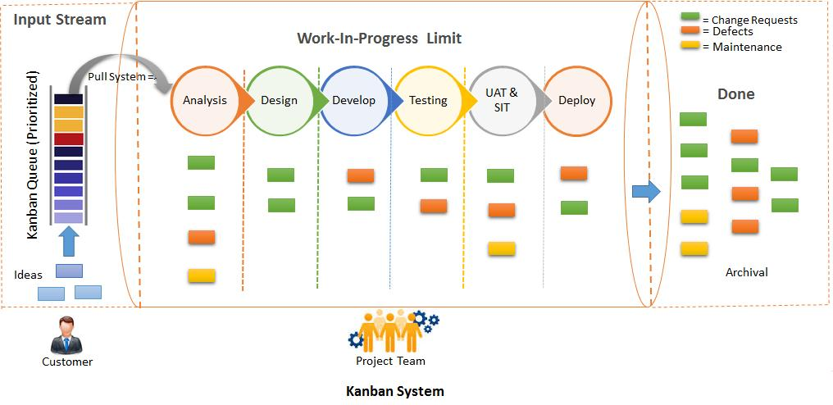
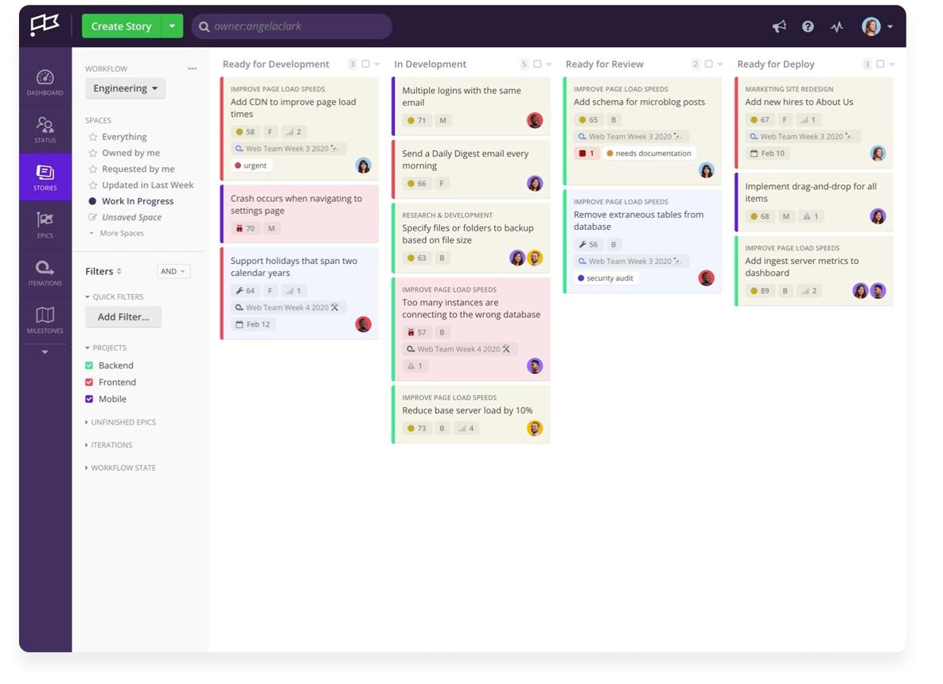
5
Kanban is another Agile approach.
It focuses heavily on visualizing work and limiting work in progress.
A simple Kanban board might look like:
To Do | In Progress | Testing | Done
Login | Payment | Search | Registration
Reviews | Cart | Profile | Database setup
A developer takes a task:
To Do → In Progress → Testing → Done

Advantages
- Very easy to visualize
- Flexible
- Tasks can be continuously added
- Useful for maintenance/support teams

Difference from Scrum
Scrum:
Work is generally organized into fixed sprints.
Kanban:
Work flows continuously.

6. V-Model
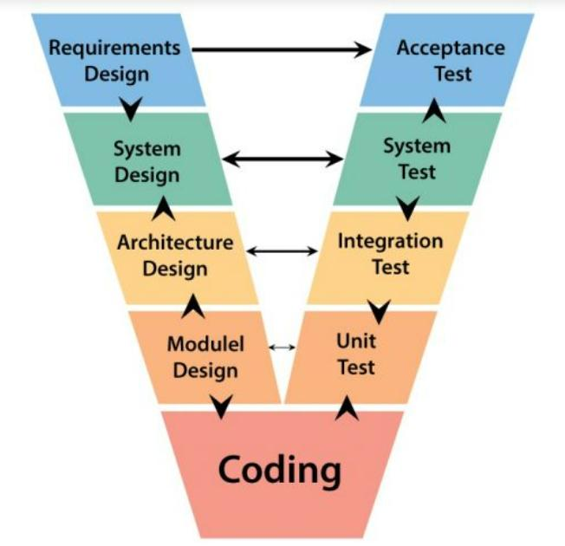
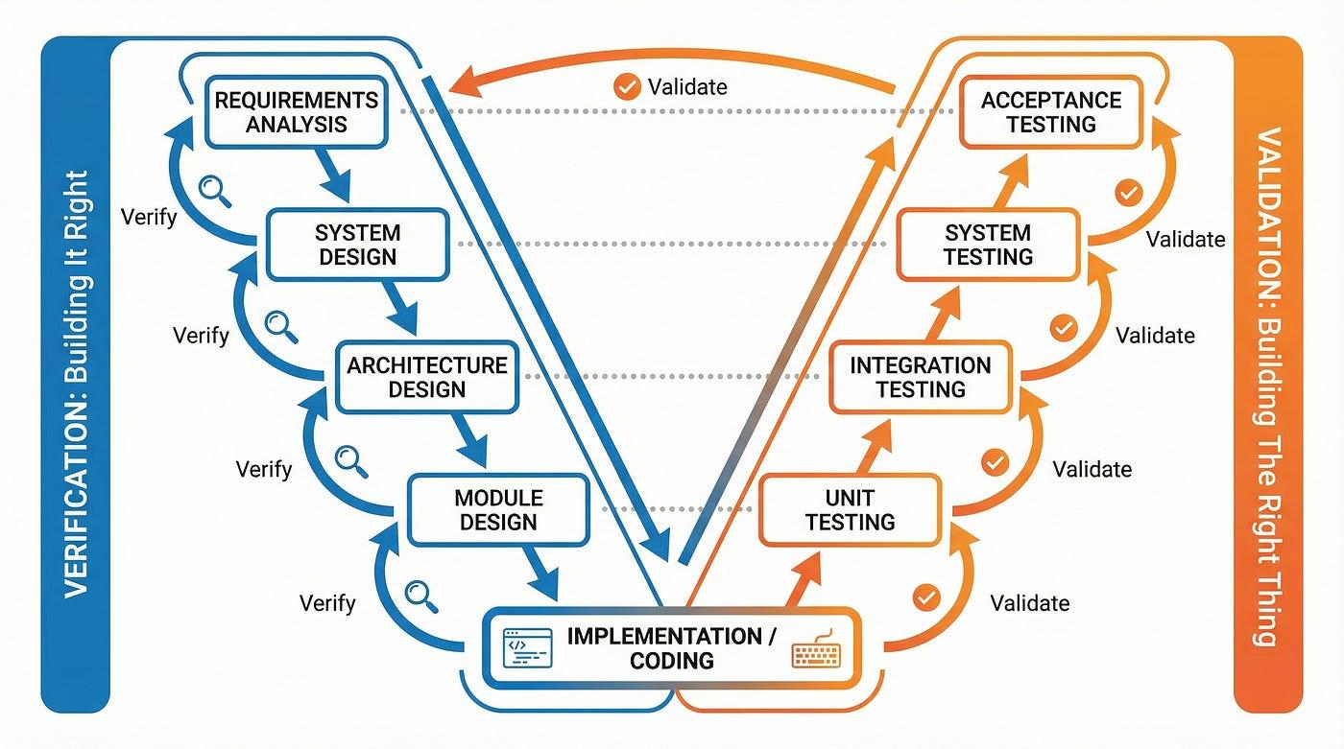
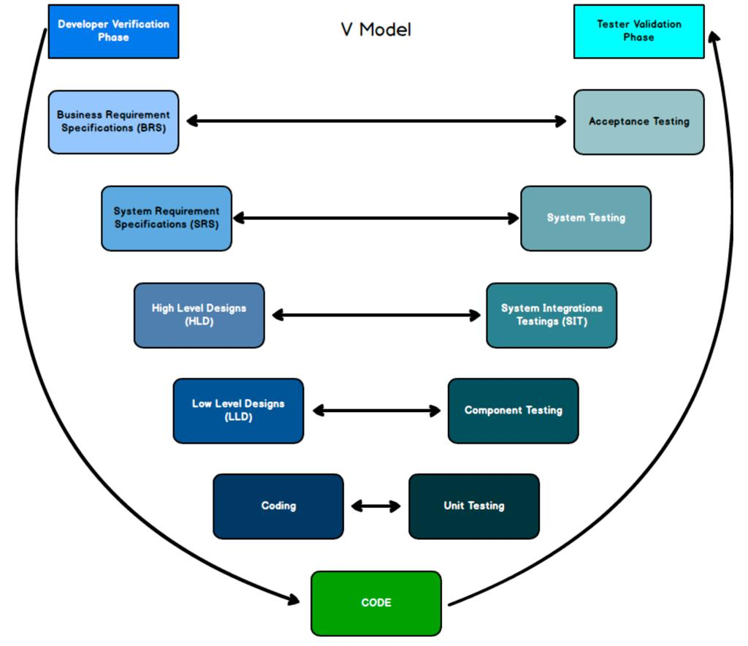
4
The V-Model is basically a development model where testing is planned alongside each development stage.
It is called the V-Model because the process is often represented as a V.
Simplified:
Requirements Acceptance Testing
↓ ↑
System Design System Testing
↓ ↑
Architecture Integration Testing
↓ ↑
Module Design Unit Testing
↓ ↑
Coding

Main idea
Instead of saying:
"We'll think about testing after coding."
the V-Model says:
"Let's plan the corresponding testing activity while we're designing the software."

Advantages
- Strong testing discipline
- Easy to understand
- Good documentation
- Useful where reliability is extremely important

Disadvantages
- Difficult to accommodate changing requirements
- Can be expensive
- Less flexible than Agile

7. Prototype Model
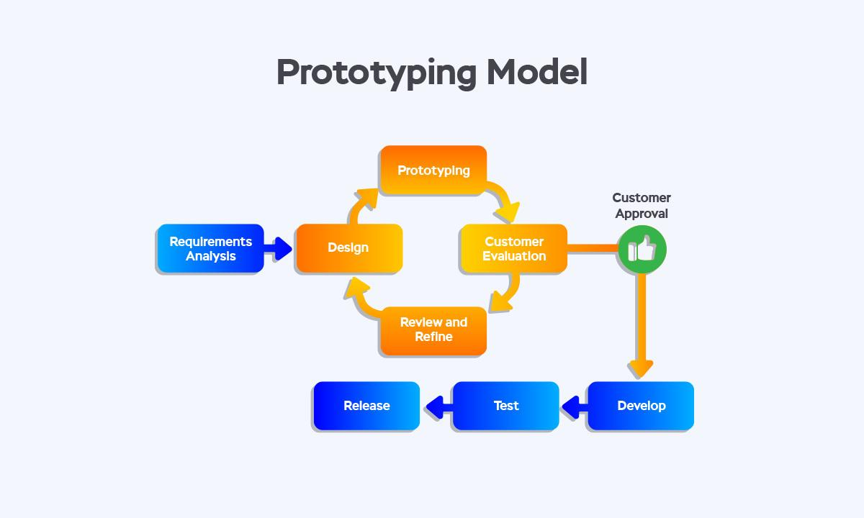
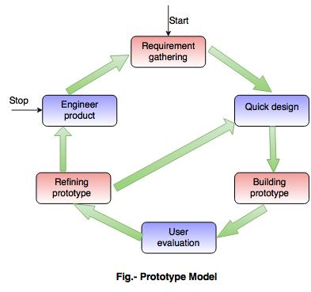
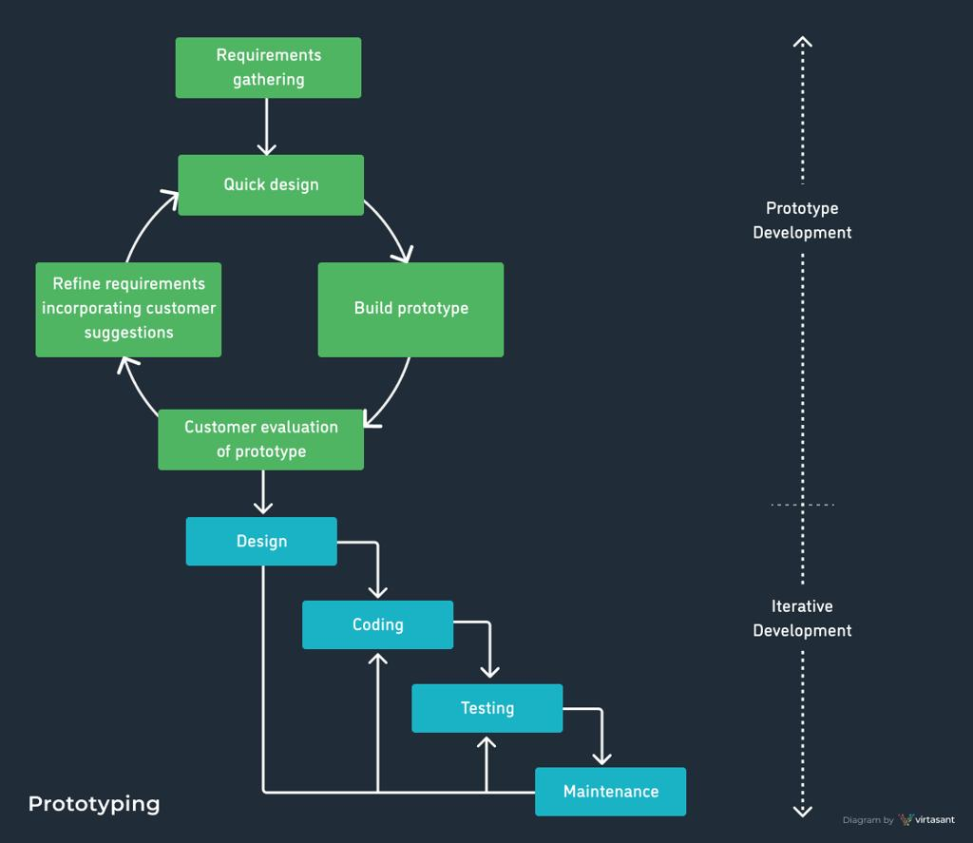
6
Sometimes customers don't know exactly what they want.
So instead of immediately building the complete application, developers create a prototype.
A prototype is a rough or limited version of the system.
For example, a customer says:
"I want a food delivery app."
You create a basic prototype showing:
- Login screen
- Restaurant screen
- Food menu
- Cart
- Checkout
The customer says:
"I don't like this checkout."
You change the prototype.
After everyone understands the requirements better, the actual system is developed.

Advantages
- Helps understand unclear requirements
- Customer can see something early
- Reduces misunderstanding

Disadvantages
- Customer might think the prototype is the final product
- Can cause scope changes
- Throwaway prototypes may waste effort if not managed properly

8. Iterative Model
Iterative means:
Build something → evaluate it → improve it → repeat.
You don't necessarily build the complete system in one attempt.

Example
Version 1:
Basic banking application
Version 2:
Add money transfer
Version 3:
Add bill payments
Version 4:
Add investment features
Each version improves the previous one.

Key idea
Repeat and improve.

9. Incremental Model
The Incremental model divides the system into smaller pieces called increments.
Each increment adds new functionality.
For example:

Increment 1
Login

Increment 2
Product catalog

Increment 3
Shopping cart

Increment 4
Payment

Increment 5
Order tracking
At the end, all increments together form the complete system.

10. Iterative vs Incremental
These two are often confused.

Iterative
Focus:
Improve what already exists.
Example:
Version 1 → improve → Version 2 → improve → Version 3

Incremental
Focus:
Add new functionality.
Example:
Login
↓
Login + Search
↓
Login + Search + Cart
↓
Login + Search + Cart + Payment
In real projects, you can use both together.
That's common in Agile development.

11. Spiral Model
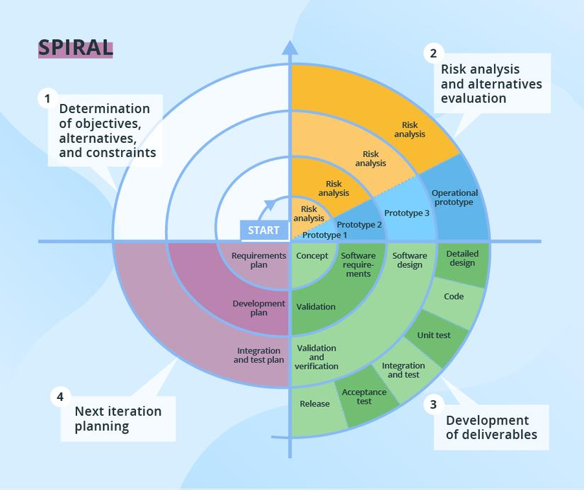
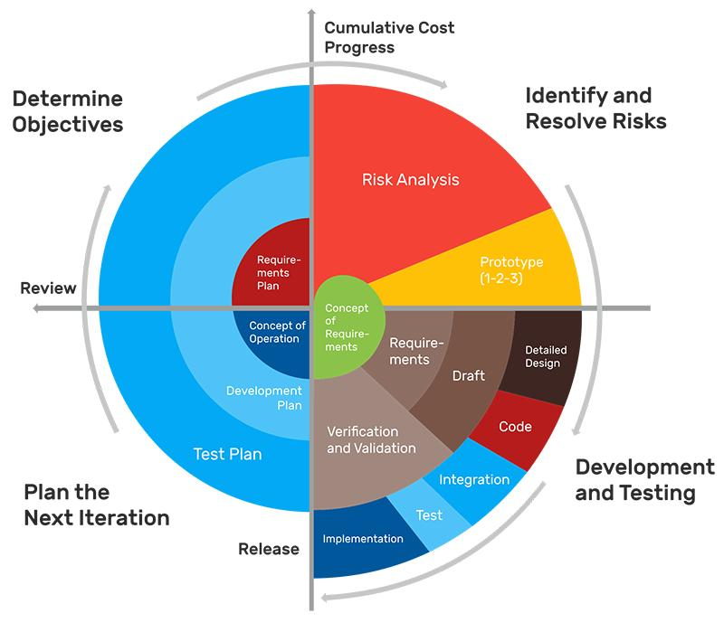
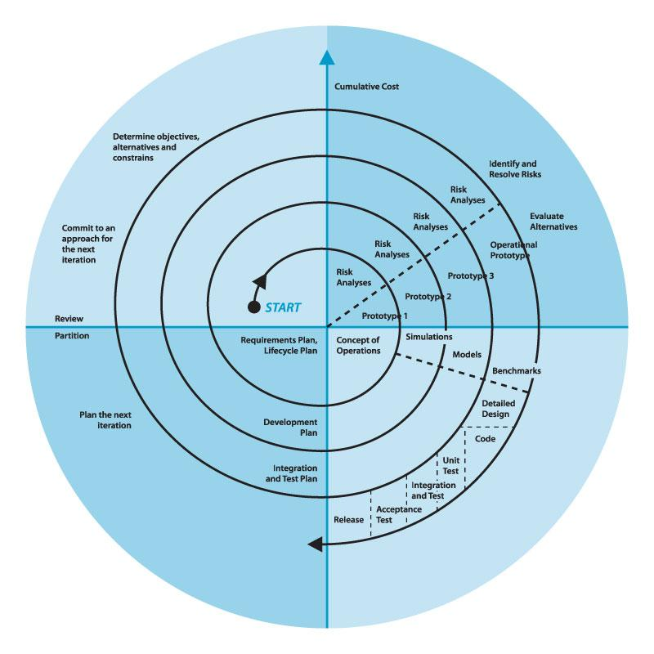
The Spiral model combines ideas from iterative development and risk management.
The most important thing about Spiral is:
Risk analysis.
Each cycle generally involves:
- Planning
- Identifying/analyzing risks
- Developing and testing
- Evaluating and planning the next cycle

Example
Suppose you're building software controlling expensive medical equipment.
A major risk might be:
"Can our software respond quickly enough?"
The team investigates that risk early.
If there is another major risk:
"Can the system handle 1 million requests?"
That gets investigated too.

Advantages
- Excellent for high-risk projects
- Risks are identified early
- Flexible
- Suitable for large and complex systems

Disadvantages
- Expensive
- Complex to manage
- Requires experienced people
- Usually unnecessary for small projects

12. RAD — Rapid Application Development
RAD stands for Rapid Application Development.
The goal is:
Build software quickly using rapid prototyping, user feedback, reusable components, and frequent development cycles.
Instead of spending a huge amount of time creating a complete specification first, developers build things quickly and get feedback.

Advantages
- Faster development
- Lots of customer feedback
- Useful when requirements evolve

Disadvantages
- Requires skilled developers
- Not suitable for every type of project
- Can become difficult for very large systems

13. Big Bang Model
The Big Bang model is one of the simplest approaches.
There is relatively little formal planning.
Developers start building and see what happens.
Basically:
"Let's start coding and figure things out."

Advantages
- Very simple
- Little planning required
- Can be useful for very small experiments

Disadvantages
- Very risky
- Difficult to predict cost/time
- Requirements can become chaotic
- Not suitable for large professional systems

Example
A student experimenting with a small application might use something similar to this approach.
You generally wouldn't use it for a $10 million banking system.

14. DevOps
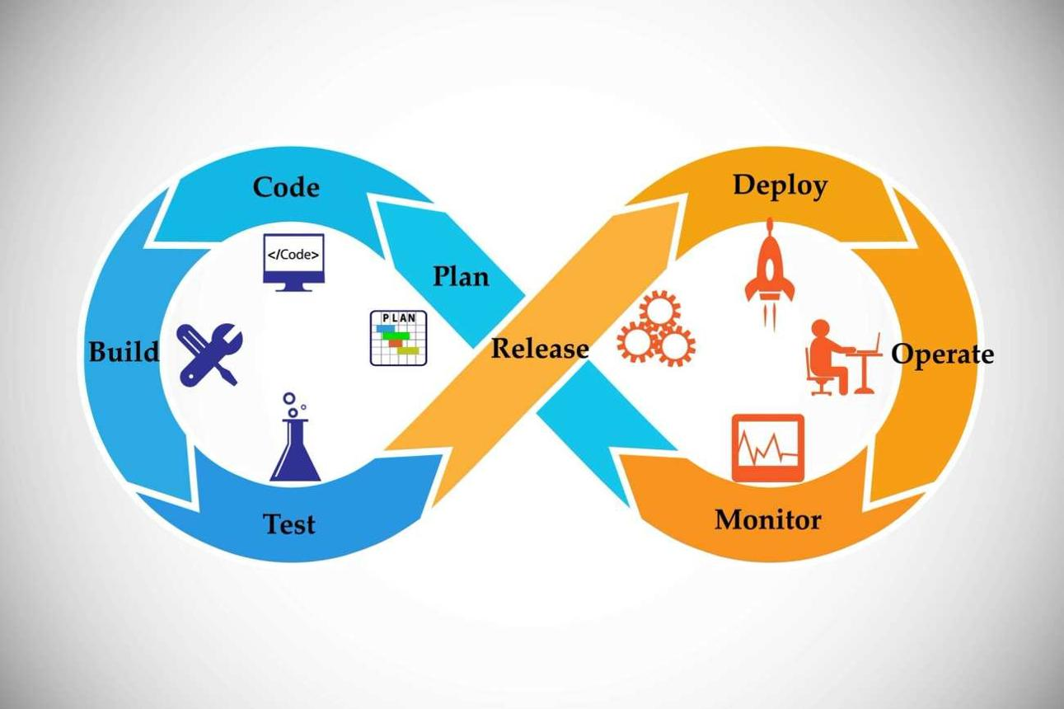
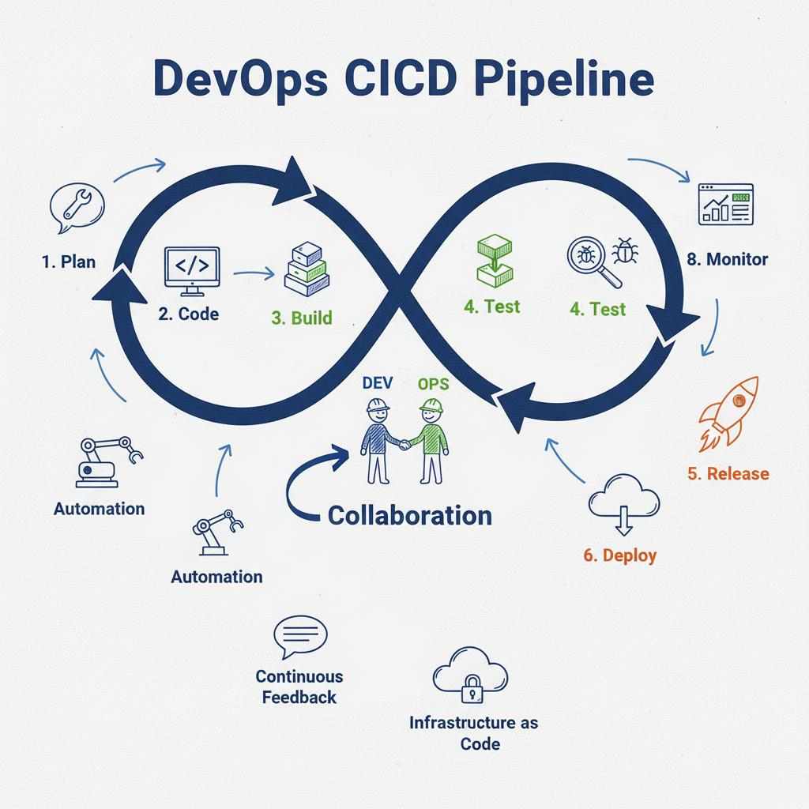
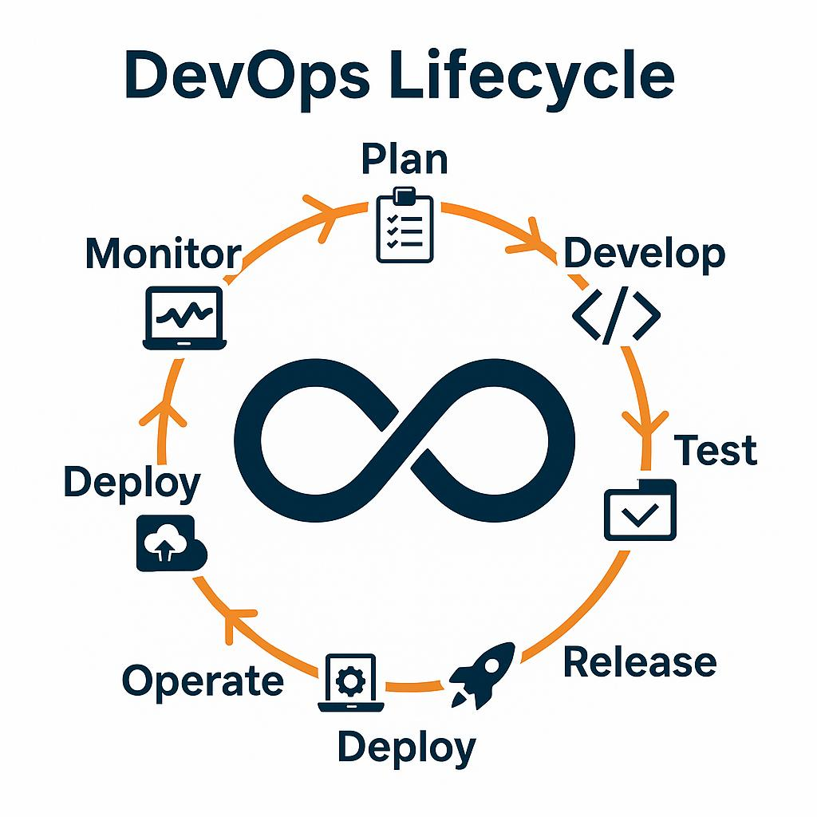
5
DevOps is a little different from the models above.
DevOps focuses on bringing development and operations together and automating the software delivery process.
Traditional organization:
Developers → Operations
Developers write the software.
Operations deploys and maintains it.
DevOps tries to create greater collaboration:
Plan
↓
Code
↓
Build
↓
Test
↓
Release
↓
Deploy
↓
Operate
↓
Monitor
↓
Feedback
↺

Important DevOps concepts

CI — Continuous Integration
Developers frequently merge code into a shared repository and automated tests/builds run.

CD — Continuous Delivery / Continuous Deployment
Software can be delivered or deployed frequently using automation.

Infrastructure as Code
Infrastructure is managed using code/configuration.

Monitoring
The team continuously monitors applications and infrastructure.

Advantages
- Faster software delivery
- More automation
- Faster feedback
- Easier deployments
- Better collaboration

15. Continuous Development / Continuous Delivery
Modern teams often continuously:
Code
↓
Build
↓
Test
↓
Deploy
↓
Monitor
↓
Improve
↺
This doesn't necessarily represent a completely separate SDLC model. It is more accurate to think of continuous delivery/deployment as practices that can be combined with Agile and DevOps.

16. Hybrid Model
A company doesn't necessarily have to use only one model.
It can combine approaches.
For example:
Requirements
↓
Waterfall-style planning
↓
Agile development
↓
Automated testing
↓
DevOps deployment
This is a hybrid approach.
Many real-world organizations work this way.

17.
Model | Main Idea | Best When
Waterfall | One phase after another | Requirements are stable
Agile | Develop in small cycles | Requirements change frequently
Scrum | Agile using sprints | Product development teams
Kanban | Continuous flow of work | Support/continuous work
V-Model | Development + corresponding testing | High reliability/testing
Prototype | Build sample first | Requirements are unclear
Iterative | Improve repeatedly | Product needs gradual refinement
Incremental | Add features piece by piece | Large system can be divided
Spiral | Iteration + risk analysis | High-risk complex projects
RAD | Fast development + prototypes | Fast application development
Big Bang | Minimal planning | Small experiments/learning
DevOps | Automate development-to-operations | Frequent reliable delivery
Hybrid | Combine approaches | Complex real-world organizations

Part 2: Monolithic vs Microservices vs Monorepo
This part is very important because these three terms are frequently mixed up.
First, remember:
Monolith and Microservices describe software architecture.
Monorepo describes how source code is stored/managed.
They are not three alternatives at the same level.

18. What is a Monolithic Application?
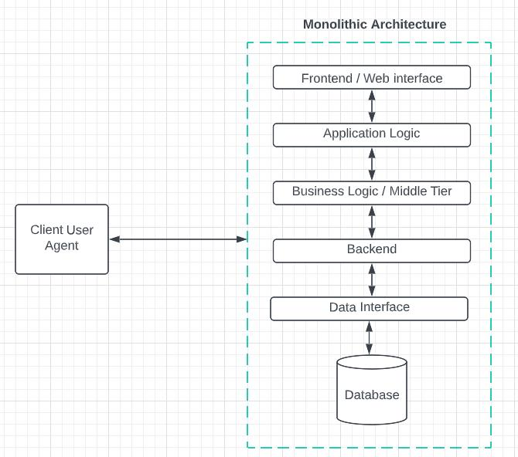
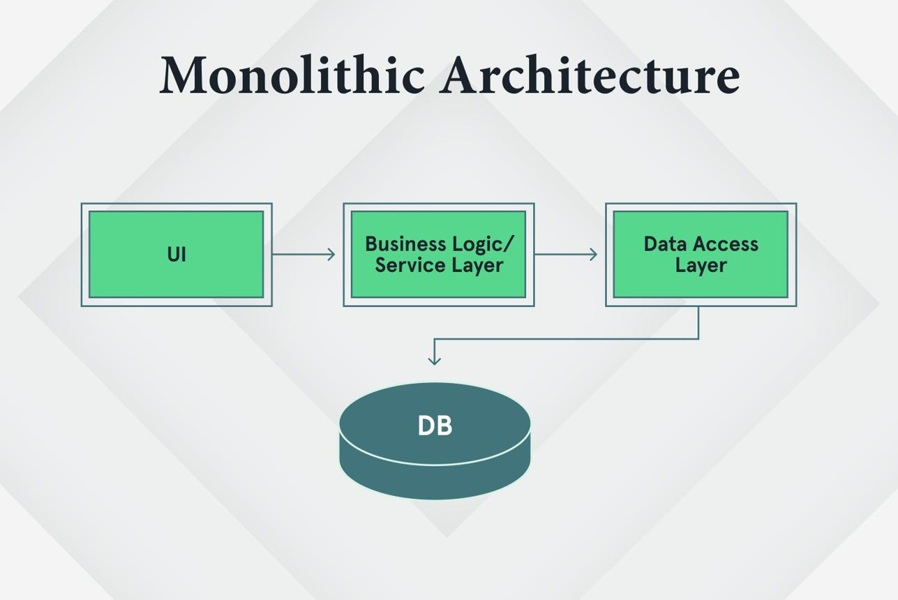
5
A monolithic application is an application where major functionality is packaged and deployed as one application.
Imagine an e-commerce application:
E-Commerce Application
|
┌──────────────┼──────────────┐
↓ ↓ ↓
Users Products Orders
↓ ↓ ↓
Payments
Everything is part of the same application.
For example:
ecommerce-app
│
├── users
├── products
├── orders
├── payments
├── reviews
└── main application
Usually, you build and deploy the application as one unit.

Example
You make a change to the payment code.
You may need to build and deploy the whole application.

Advantages
- Simple to start
- Simple to develop
- Simple to test initially
- Easy local development
- Easy deployment at small scale
- Good for small/medium applications

Disadvantages
As the application becomes huge:
- Codebase becomes difficult to understand
- Changes can become risky
- Deployment becomes larger
- Scaling individual components is harder
- Teams can interfere with each other
- One problematic component can affect the whole application

19. What are Microservices?
5
Instead of making one giant application, we split the system into multiple smaller services.
For example:
E-Commerce System
|
┌──────────────┼───────────────┐
↓ ↓ ↓
User Service Product Service Order Service
| | |
DB 1 DB 2 DB 3
|
Payment Service
|
DB 4
Each service focuses on a particular business capability.
For example:

User Service
Handles:
- Registration
- Login
- Profiles

Product Service
Handles:
- Products
- Categories
- Inventory

Order Service
Handles:
- Creating orders
- Order status
- Order history

Payment Service
Handles:
- Payments
- Refunds
- Payment status
These services communicate through mechanisms such as APIs or messaging systems.

20. Why use Microservices?
Imagine Amazon has a huge application.
Suppose the payment functionality becomes extremely busy.
With a monolith:
Entire Application
↑
Scale everything
With microservices:
User Service 3 instances

Product Service 5 instances

Order Service 10 instances

Payment Service 30 instances
You can scale the Payment Service independently.
That's one of the major benefits.

21. Advantages of Microservices

1. Independent deployment
You can potentially deploy one service without deploying every service.

2. Independent scaling
If payment requires more resources, scale payment.

3. Team independence
Different teams can own different services.

4. Fault isolation
A failure in one service can potentially be contained rather than bringing down everything, if the system is designed properly.

5. Technology flexibility
Different services can sometimes use different technologies.
For example:
User Service → Java
Product Service → Go
Recommendation → Python
However, using many technologies also increases operational complexity.

22. Disadvantages of Microservices
Microservices aren't automatically better.
They introduce significant complexity.
You now have:
Service A
Service B
Service C
Service D
Service E
Service F
...
Now you need to think about:
- Network communication
- Service discovery
- Authentication
- Monitoring
- Logging
- Distributed tracing
- Deployment
- Versioning
- Data consistency
- Failures between services
- Infrastructure
- Security

Simple example
In a monolith:
Order → Payment
could simply be a function call inside the same application.
In microservices:
Order Service
|
| HTTP/gRPC/message
↓
Payment Service
Now the network can fail.
That's a new problem you didn't have inside a single process.

23. What is a Monorepo?
Now comes the confusing one.
Monorepo = Monolithic Repository.
More commonly, people say monorepo.
A monorepo means:
Multiple applications/services/packages are stored in one source-code repository.
For example:
my-company/
│
├── frontend/
├── mobile-app/
├── user-service/
├── payment-service/
├── order-service/
├── shared-library/
└── documentation/
All of these can live inside one Git repository.
That is a monorepo.

24. Monorepo Does NOT Mean Monolith
This is extremely important.
You can have:

Monolithic application + monorepo
Git Repository
↓
One Monolithic Application
Or:

Microservices + monorepo
Git Repository
|
├── User Service
├── Order Service
├── Payment Service
└── Product Service
Those are microservices, but they are stored in one repository.
You can also have:

Microservices + multiple repositories
Git Repo 1 → User Service

Git Repo 2 → Order Service

Git Repo 3 → Payment Service

Git Repo 4 → Product Service
This is commonly called a polyrepo/multi-repo approach.

25. Monorepo vs Polyrepo

Monorepo
One repository:
company/
├── frontend
├── backend
├── service-a
├── service-b
└── shared-library

Polyrepo
Multiple repositories:
frontend-repo
backend-repo
service-a-repo
service-b-repo
shared-library-repo

26. Why use a Monorepo?
Suppose your company has:
Frontend
Backend
Mobile App
Payment Service
User Service
Shared Components
With a monorepo, all the code can be managed in one place.

Advantages
- Easier code sharing
- Easier cross-project changes
- One place for common tooling
- Easier visibility across projects
- Easier to keep shared libraries synchronized
- Can simplify dependency management

Disadvantages
- Repository can become very large
- Build systems can become complicated
- CI/CD needs to be carefully designed
- Poor organization can make the repository difficult to manage
Tools such as Nx, Turborepo, and Bazel are often used to help manage large repositories, depending on the technology and organization.

27. Monolith vs Microservices vs Monorepo
Here's the most important comparison:
Feature | Monolith | Microservices | Monorepo
What is it? | Architecture | Architecture | Repository strategy
Main idea | One application | Many independent services | One source repository
Deployment | Usually one application | Services can deploy independently | Depends on architecture
Code repository | Can be one or many | Can be one or many | One repository
Database | Often shared | Often each service owns its data | Not defined by monorepo
Scaling | Usually application-level | Service-level | Not applicable
Communication | Often function calls | Network/API/message calls | Not applicable
Complexity | Lower initially | Higher | Repository-management complexity
Best for | Smaller/simple systems | Large/complex systems | Coordinating related codebases

28. The Most Important Concept
Don't think:
Monolith
vs
Microservices
vs
Monorepo
as three competing architectures.
Instead think in two dimensions.

Dimension 1 — Application architecture
Monolith
OR
Microservices
OR
other architectures

Dimension 2 — Repository organization
Monorepo
OR
Multiple repositories
Therefore:
Architecture | Repository | Possible?
Monolith | Monorepo | ✅
Monolith | Multiple repos | ✅
Microservices | Monorepo | ✅
Microservices | Multiple repos | ✅

29. Real Example
Imagine you're building a food delivery platform.

Option A — Monolith + Monorepo
Git Repository
│
└── Food Delivery Application
├── Users
├── Restaurants
├── Orders
├── Payments
└── Delivery
One main application.
One repository.

Option B — Microservices + Monorepo
Git Repository
│
├── user-service
├── restaurant-service
├── order-service
├── payment-service
└── delivery-service
Multiple services.
One repository.

Option C — Microservices + Multiple Repositories
user-service-repo
restaurant-service-repo
order-service-repo
payment-service-repo
delivery-service-repo
Multiple services.
Multiple repositories.

30. Which One Should a Beginner Choose?
If you're learning software development, don't start by making everything microservices.
A good learning progression is:
Simple application
↓
Monolithic architecture
↓
Understand APIs
↓
Understand databases
↓
Understand deployment
↓
Learn Docker
↓
Learn CI/CD
↓
Learn distributed systems
↓
Learn Microservices
Why?
Because microservices solve problems that you often don't have yet when your application is small.
Starting with 15 microservices can turn:
"I want to build a website"
into:
"Why isn't Service 7 talking to Service 12?" 😄

31. One Final Mental Model
If you remember only this, remember this:

Development model
How do we develop the software?
Examples:
Waterfall
Agile
Scrum
Kanban
Spiral
V-Model
Prototype
Iterative
Incremental
RAD
DevOps

Architecture
How do we structure the application?
Examples:
Monolith
Microservices
Serverless
Event-driven
Layered architecture
etc.

Repository strategy
Where/how do we organize the source code?
Monorepo
Multiple repositories / Polyrepo

Deployment strategy
How do we deliver the software?
Examples:
Manual deployment
CI/CD
Continuous Delivery
Continuous Deployment
Blue-Green deployment
Canary deployment
etc.
So a real company could have:
Agile + Scrum + Microservices + Monorepo + DevOps + CI/CD
There is no contradiction there. These concepts operate at different levels.

